DLB Lab -4

Tasks

Roll no: 23K-2001
BCS 2-J

Exercise#01 & Exercise#02:
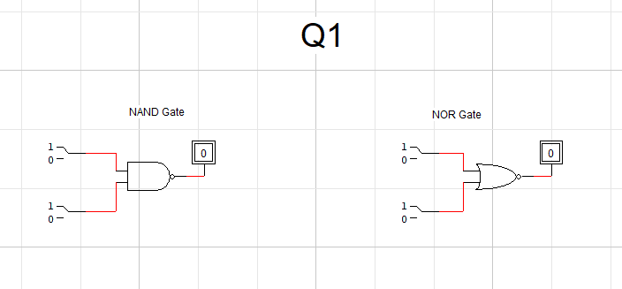
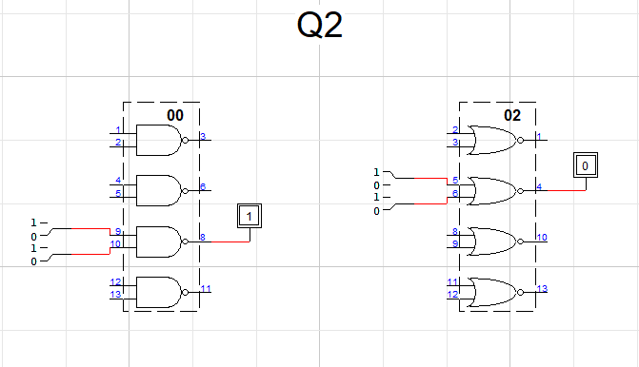
Exercise#03:
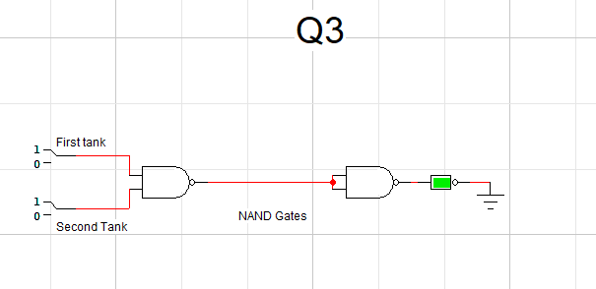
Exercise#04:
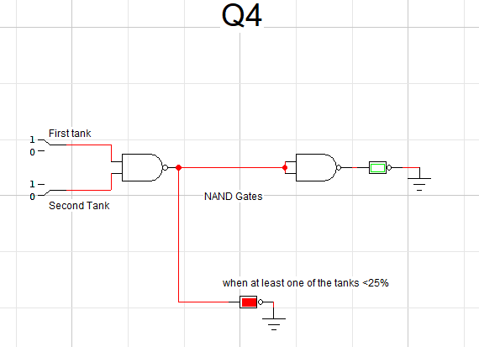
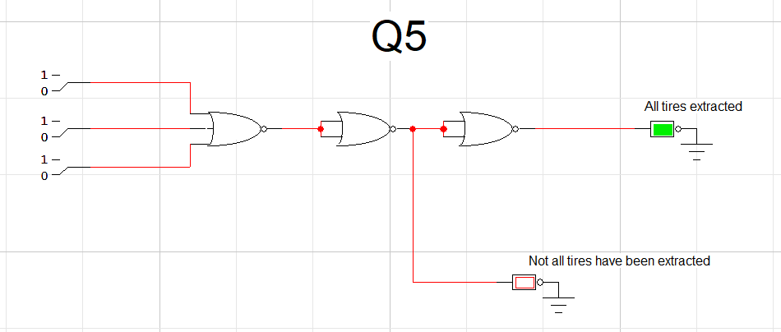
Exercise#05:

Tire A | Tire B | Tire C | Output(green)
0 | 0 | 0 | 1
0 | 0 | 1 | 0
0 | 1 | 0 | 0
0 | 1 | 1 | 0
1 | 0 | 0 | 0
1 | 0 | 1 | 0
1 | 1 | 0 | 0
1 | 1 | 1 | 0

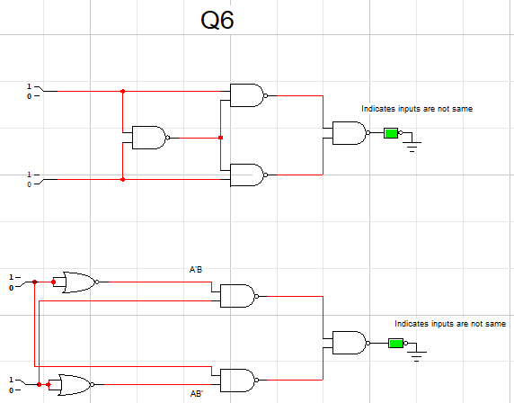
Exercise#06:

Xor Table
0 | 0 | 0
0 | 1 | 1
1 | 0 | 1
1 | 1 | 0

True/False

- True
- True
- False
- False
- True
- True
- False

